Step | Action | Result
 | *Please see instructions on how to navigate to this portion of the Credentialing Profile in the Job Aid “Editing a Credentialing Profile (Organizational Providers)”
 | To add a Service Location, select “Add a Service Location” and click “Next”. | A list of all available service locations will display.
 | Select all applicable Service Locations and click “Next”.  *If you do not see one of your service providers listed, please submit a request for it to be added by accessing the "Universal Credentialing Provider Entity Template (Service Locations)" located under the "Files" tab at the top of your screen.  Files > Libraries > Job Aids - Partners > Universal Credentialing > Organizational Providers  Once the template is complete, please send it to the PIHP or CMSHP who initiated your credentialing application. To avoid sending multiple templates, please send the finalized template of missing service locations once you have entered all other existing service locations. Your PIHP/CMHSP will receive an email confirmation once the locations on the template have been added (typically within two business days dependent on the volume of requests the team is working through). Only after receiving the confirmation email will you be able to proceed with adding the providers.  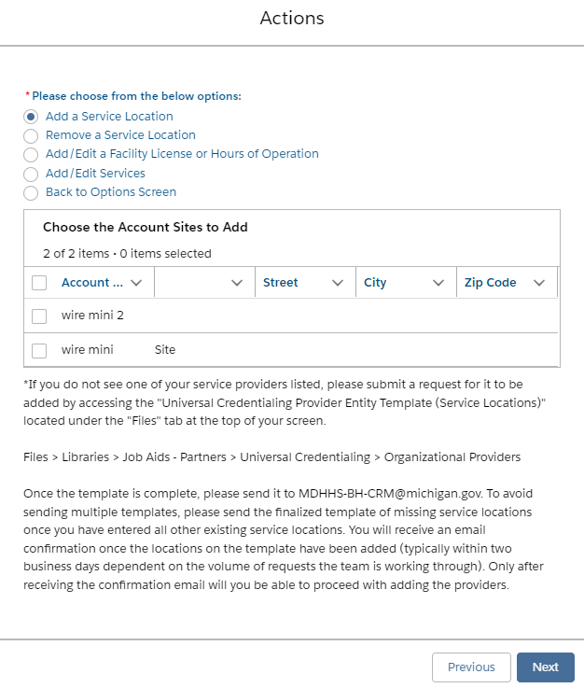 | Message “Service Locations have been successfully added to the credentialing profile” will display, along with the added Service Location.
 | “Add/Edit” services will automatically be selected. Select the Service Location(s) to add/edit services and click “Next” to proceed.  *Multiple locations may be selected when adding services. Please note that any selected services will be added to all selected locations. The service will be indicated in bold font as shown below.  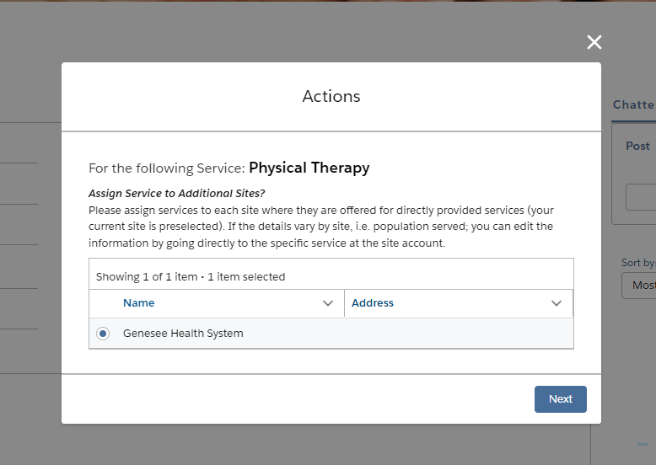 | Service listing will display with the Service Location(s) the services are being added to at the top.
 | Select all applicable services.  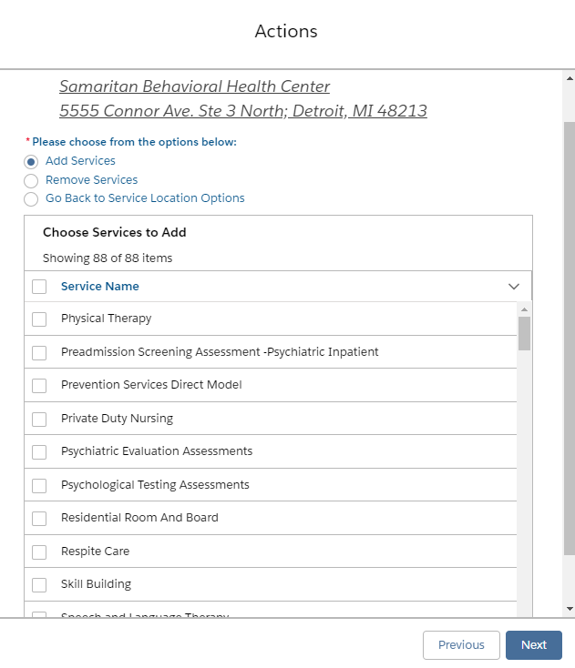 | Message “Services have been successfully created for the Service Location” will display.
 | If finished adding/removing services, select “Go Back to Service Location Options”.
 | Select “Add/Edit a Facility License or Hours of Operation”, select the desired “Service Location”, and click “Next”. | Add/Edit Facility License or Hours of Operation fields will display.
 | Complete all required fields/documentation uploads.  Please note, if this is a licensed facility, you must check the “Licensed Facility” box for the “Facility License Expiration” and “Facility License Number” text boxes to be visible.  Once required fields are completed, click “Next”.  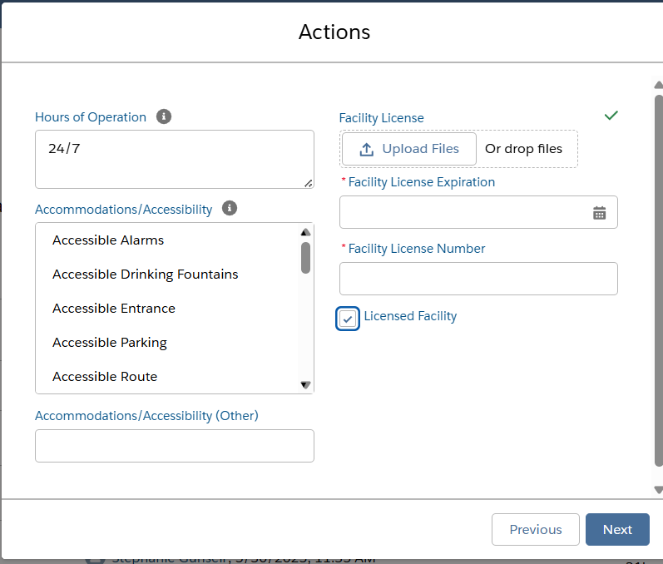 | Message “The facility license has been successfully added/modified for this location” will display. User is directed back to “Actions” menu.
 | If all “Service Location” edits are complete, select “Complete Edits”. | Message “Successfully edited the Service Locations for the Credentialing Application of: [Organizational Provider] – Credentialing – [Date]  Click Finish to view Edits” will display.
 | Click “Finish”. | User is directed to main application. Must re-select “Actions” and “Edit Application” to proceed to next section.

