Autism Monthly Reports into CIGMMO Charts
- Starting Oct. 1, 2026 ABA clinicians will enter monthly reports in the CIGMMO charts of all CMHCM consumers authorized for services.
- Reports need to be completed by the 15th each month and must include the following:
  - Number of Direct ABA (97153) Units authorized per Week*
  - Number of Direct Hours provided for the identified Month
  - Number of Supervision Hours (97155) provided for the Month
  - Number of Parenting Sessions (97156) provided for the Month
  - If any changes are needed to update auths or goals
- Reports need to be copied to Karen Chapin using the Send Copy To button.
- Reports need to be signed by the supervising behavior analyst.
  - They can be completed by someone else, but the BCBA/BCaBA must review and sign each month.

Step by Step Directions for Entering Autism Monthly Reports into CIGMMO Charts
- To enter a new report go to the purple Autism section in the chart.
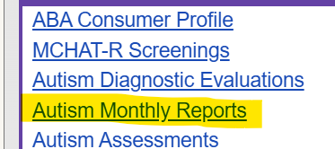
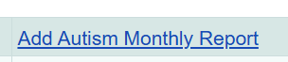

- Select Month/Year for the report and Lookup your Provider agency. If there were active authorizations for your agency during the selected month they will appear in a link below the Units. Select link for it to auto fill the Units. 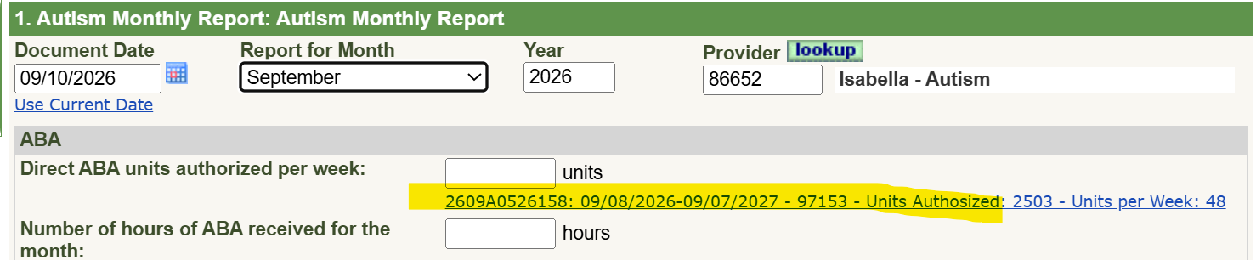

- ABA: Manually enter the number of HOURS of direct ABA that were provided that month. The percentage will automatically calculate. If the percentage is below 75% you are required to provide additional information in the next box. 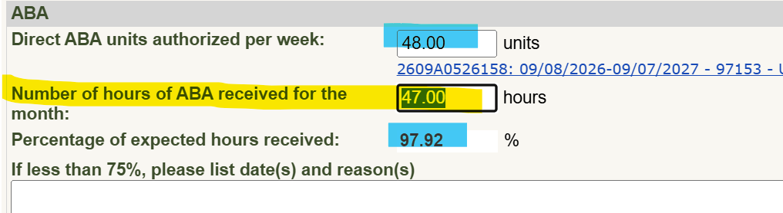
- Answer the questions about offering Make Up hours and Inactivity.
- SUPERVISION: The Minimum number of hours of Supervision is automatically entered based on the number of hours provided for the month. Manually enter the number of HOURS of supervision provided for the month. If the percentage is below 10% you are required to provide additional information in the next box. 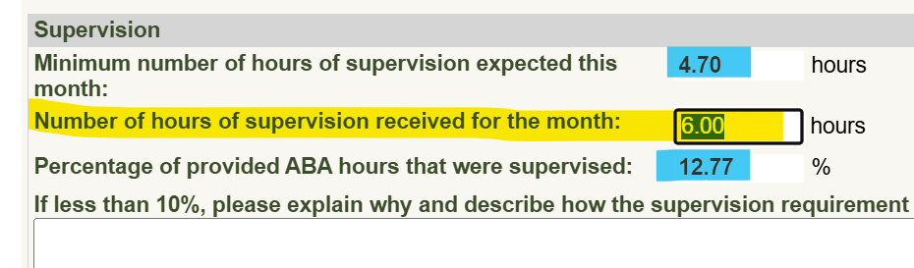
- PARENT TRAINING: Manually enter the number of SESSIONS provided for the month, even if it was 0. Enter the total number of minutes and list topics discussed. 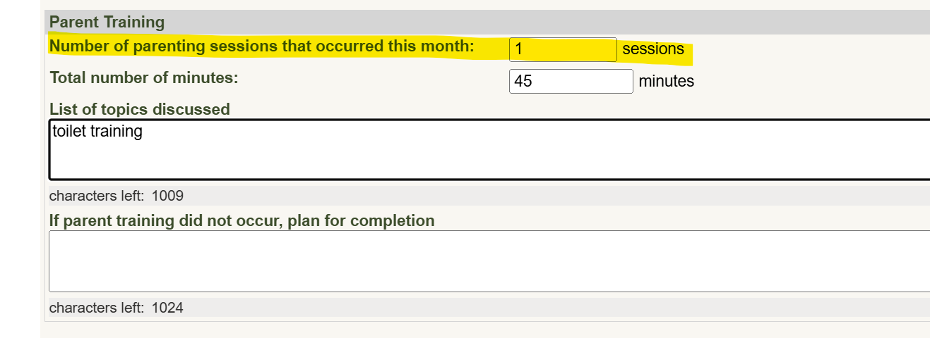

- Answer Transportation questions. If it was provided, attach a Transportation Log. 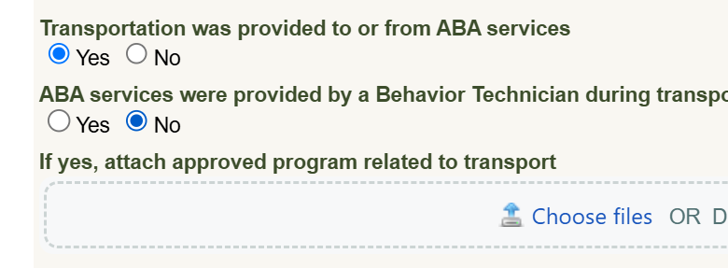
- Provide summary of ABA services AND/OR select PCP Goals and Objectives worked on during the past month and identify current state of progress. 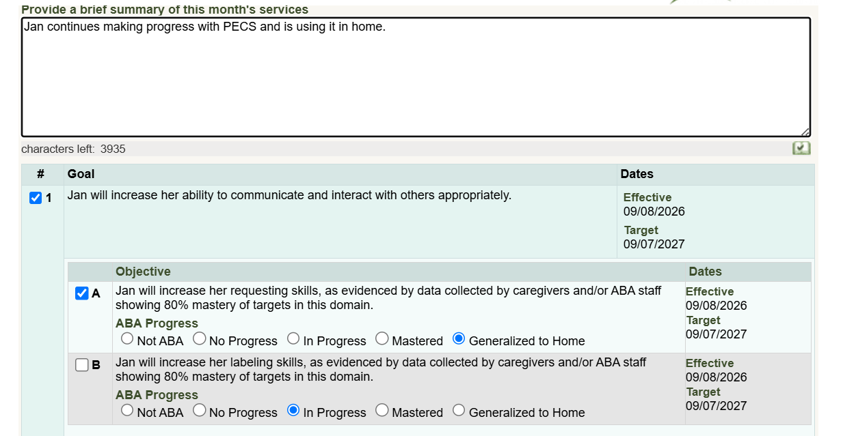
- Answer if any changes are needed to the current ABA auths or goals. If yes, attach the signed ABA Authorization Request Form. Note whenever there is any reductions of auths or pause of services the case holder is required to send a notice to the consumer/family, giving them 10 days to appeal. Please immediately enter a non-billable note that is copied to case holder as an alert.
- Save and Continue to Send Copy To. Or choose it in the Index. 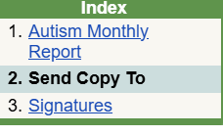
- Select Send to Staff.
- Enter Karen Chapin’s name in Lookup or Enter her Staff #188340. 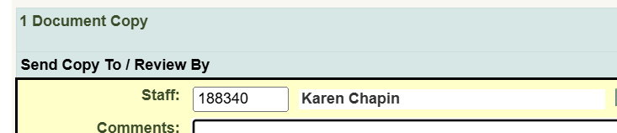
- Save and Continue to Signatures Or choose it in the Index. 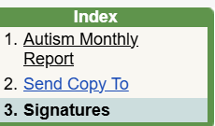
- Rendering Clinician must sign with password.
If someone else is entering the data for the clinician select LOOKUP above the Staff Signature name and change it to the Rendering Clinician who will then need to enter, review and verify what has been entered, and sign with password.
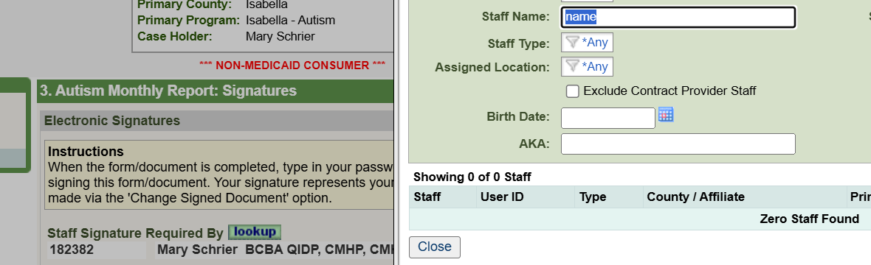

If required fields are left blank you might get an error like this to prompt corrections. 

