Autism Assessments and Authorization Requests
To bill for an autism assessment, the report needs to be uploaded into the purple Autism Assessment section in CIGMMO. The date of entry needs to match the FINAL DAY that is included in the assessment process. This must be completed (entered, uploaded and signed by rendering clinician) prior to billing for each Autism Assessment.
Everything with blue notes are required fields.
Initial Evaluation: first ABA evaluation
Second Evaluation: any semi-annuals
Other: First with new provider; Parent training only
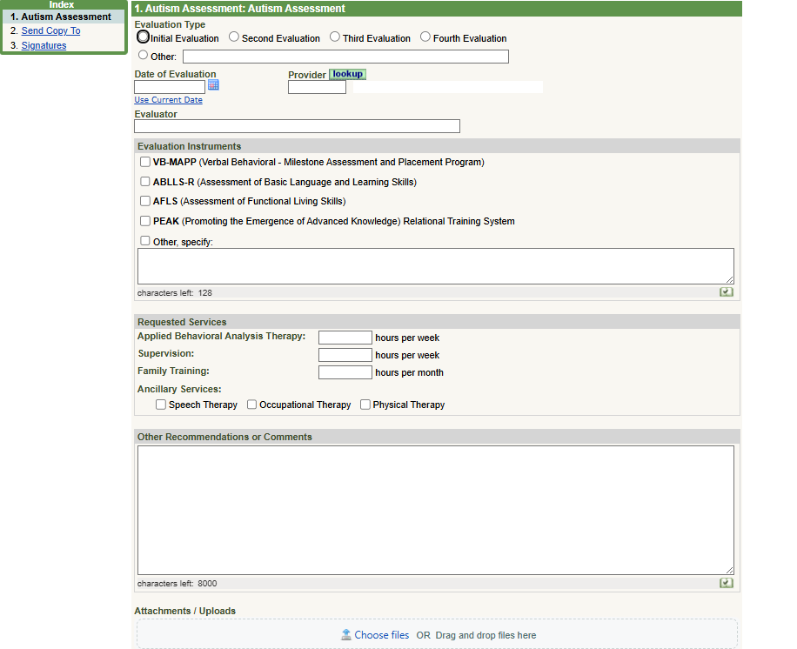
Date of Evaluation: final day of evaluation
Provider: ABA agency
Evaluator: Rendering clinician w credentials

Requested Service: hours to be authorized
Comments: ABA schedule/school schedule

Enter dates and times spent on assessment.

Choose File: to attach Current ABA assessment/treatment plan

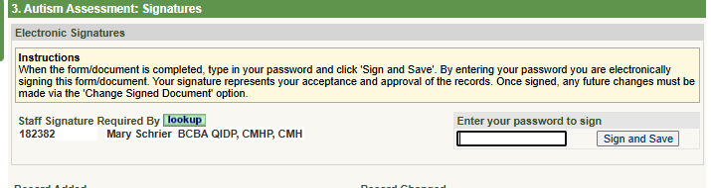

Signature: must be signed by rendering clinician

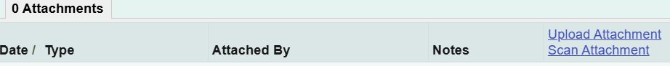
Documents can also be attached after signing and closing by choosing:
Files that need to be attached:
Current ABA assessment/treatment plan
Documentation of training techs on this plan
Authorization request

When Non-Clinical Staff uploads assessments:
If staff other than rendering clinician enters this and uploads documents, follow directions to change Staff Signature line to rendering clinician.

Changing Staff Signature to Rendering Clinician:
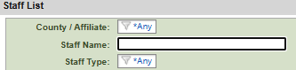

Lookup: select to find rendering clinician

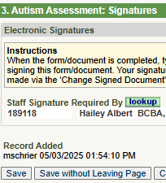
Staff Signature: after entering rendering clinician Save

Document will show as Unsigned until Clinician signs.

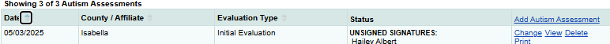

Rendering Clinician Responsibilities:
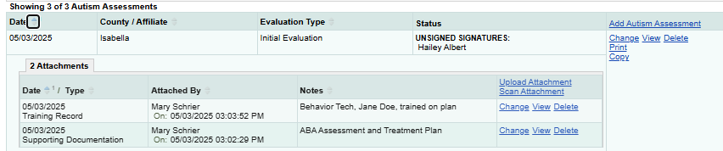
Open Assessment document in CIGGMO by clicking Change

Change: to open, review and sign

Attachments: current assessment, training records, and addendum requests

Review that everything entered and uploaded are correct, then sign final page of entry.

To request authorizations:
Complete the Auth Request form https://www.cmhcm.org/userfiles/filemanager/ni5essjfuriekhpb6qlk/ and have it signed by caregiver to ensure they agree with the start date and schedule.
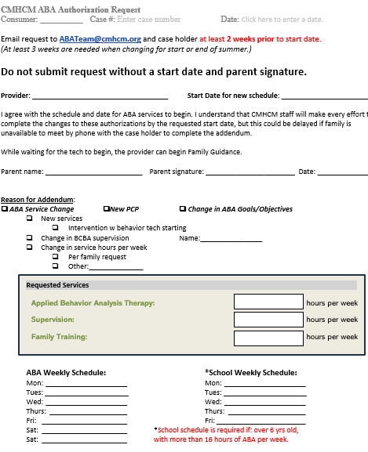
Upload Auth Request form to the Autism Assessment section.
Make sure the request matches the Requested Services in the Autism Section.
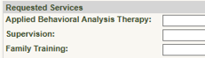
If it doesn’t match the clinician needs to Change Signed Document to update the hours.

Email ABATeam@cmhcm.org letting them know that the auth request has been uploaded.
Request form must include: Requested Start Date, Parent Signature and must be at least 2 weeks prior to start.

