Completing Your Credentialing Profile
STEP | ACTION
1 | Once a Universal Credentialing application has been created by the CMHSP, you will receive an email similar to the one below. Click the hyperlink that best fits.  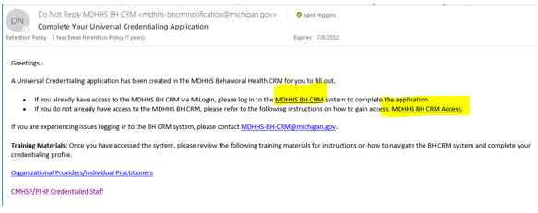
2. | MDHHS’s Universal Credentialing is housed within the MiLogin for Business page. Enter your User ID and Password.  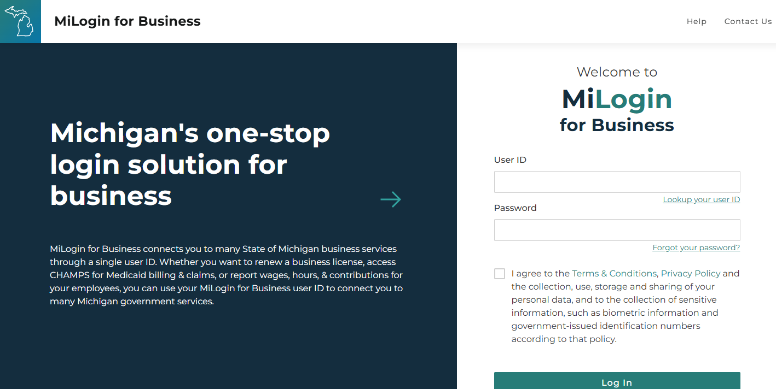
3. | Your Main Screen may have more options; however, you will want to click on BH CRM/Michigan Crisis and Access Line.  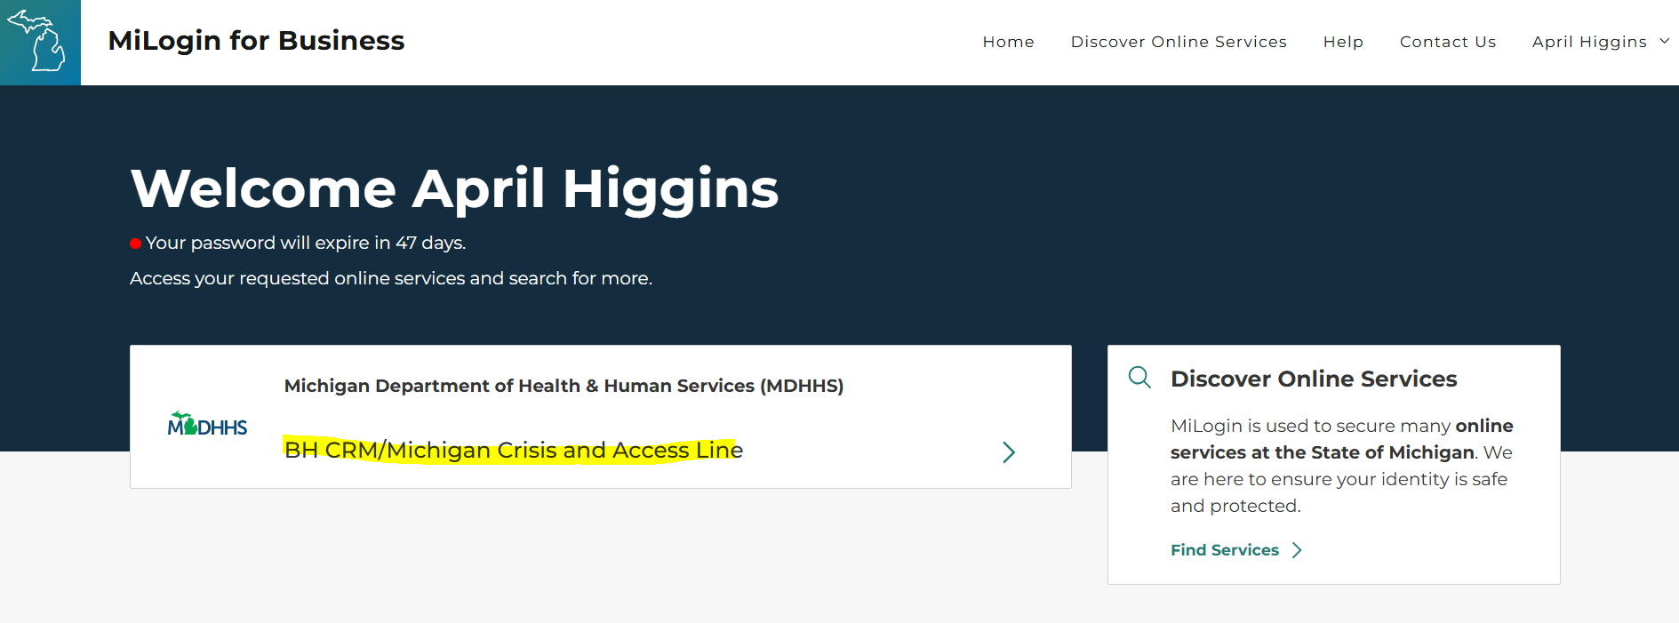
4. | Read the Terms & Conditions, Click Agree, then Click Launch service.  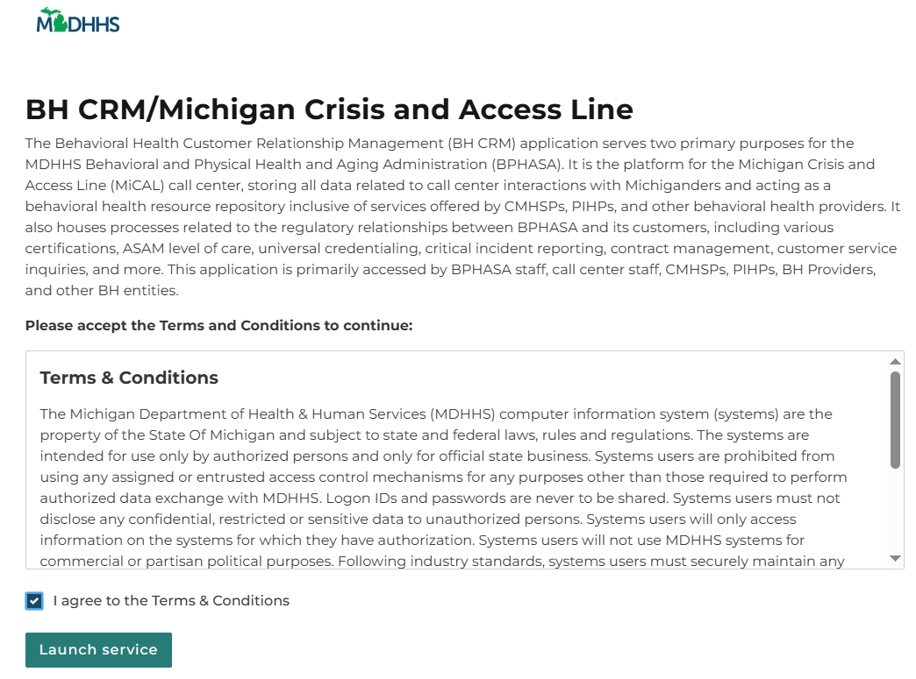
5. | Choose your verification method.  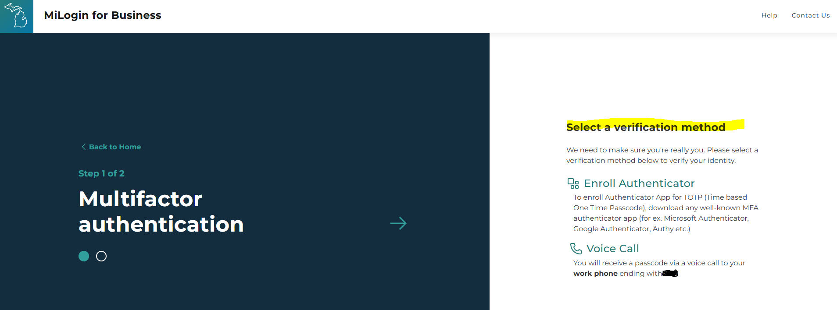
6. | From the Home page, click the Credentialing Profile at the top of the screen.  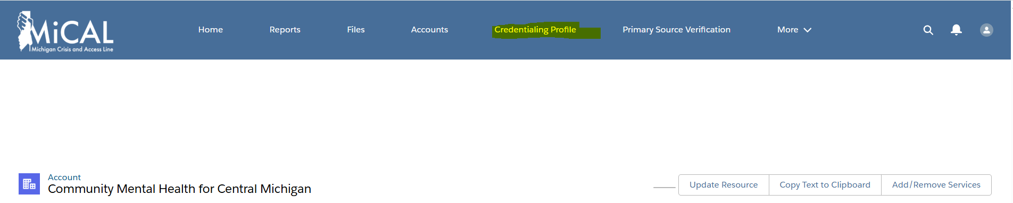
7. | Select All Credentialing Profiles  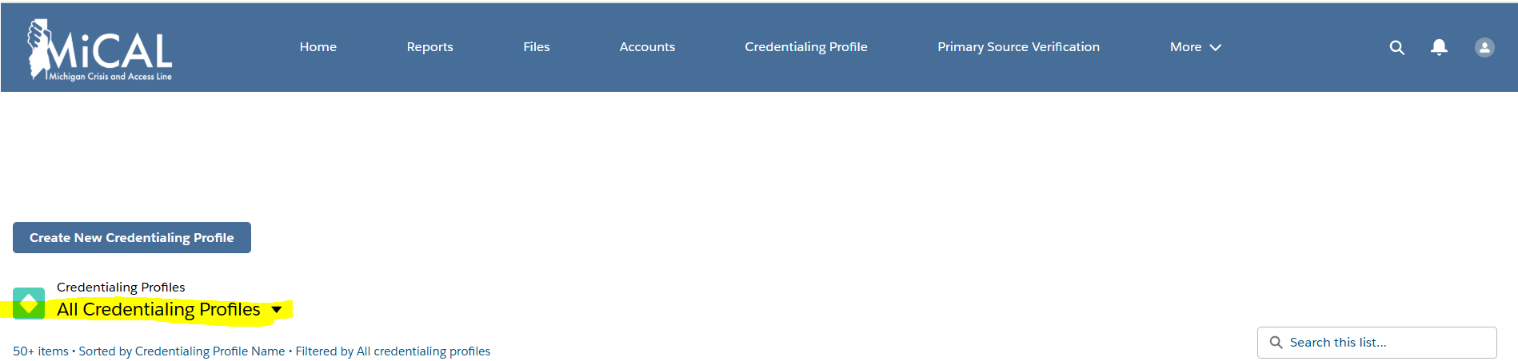
8. | A dropdown box will appear. Select My Credentialing Profile.  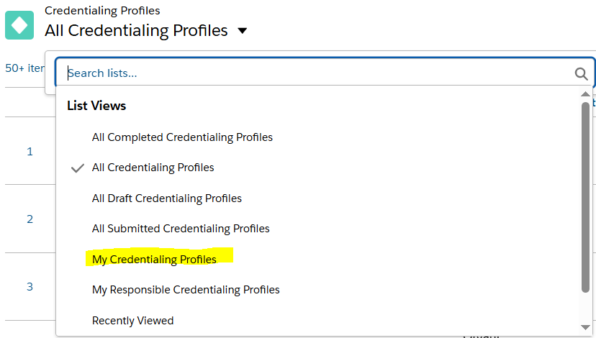
9. | Click on your agency’s name.  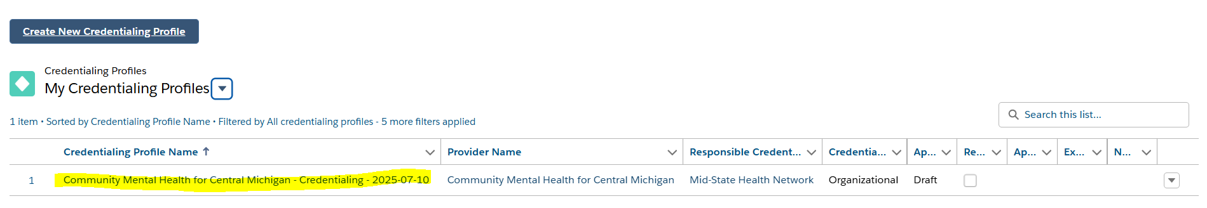
10. | A pop up will appear. Please read and click the appropriate choice.  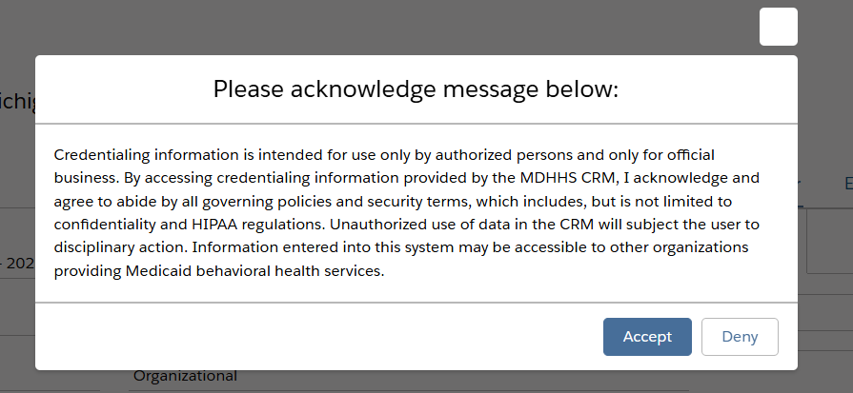
11. | If you click Accept above, your agency’s Universal Credentialing Application will appear. You must now complete the Credentialing Profile.  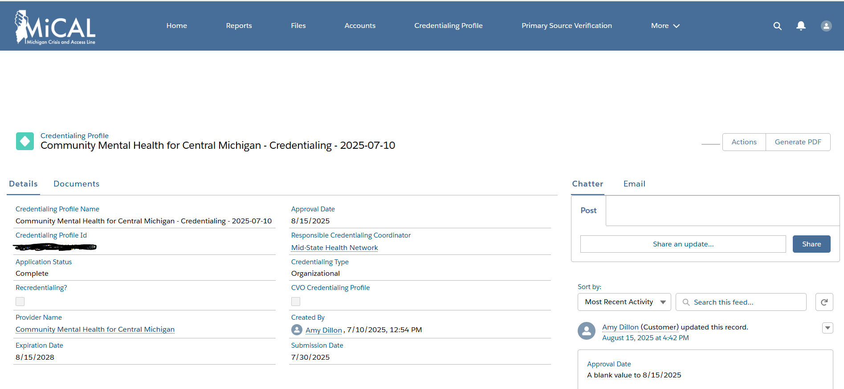
12. | Click Actions.  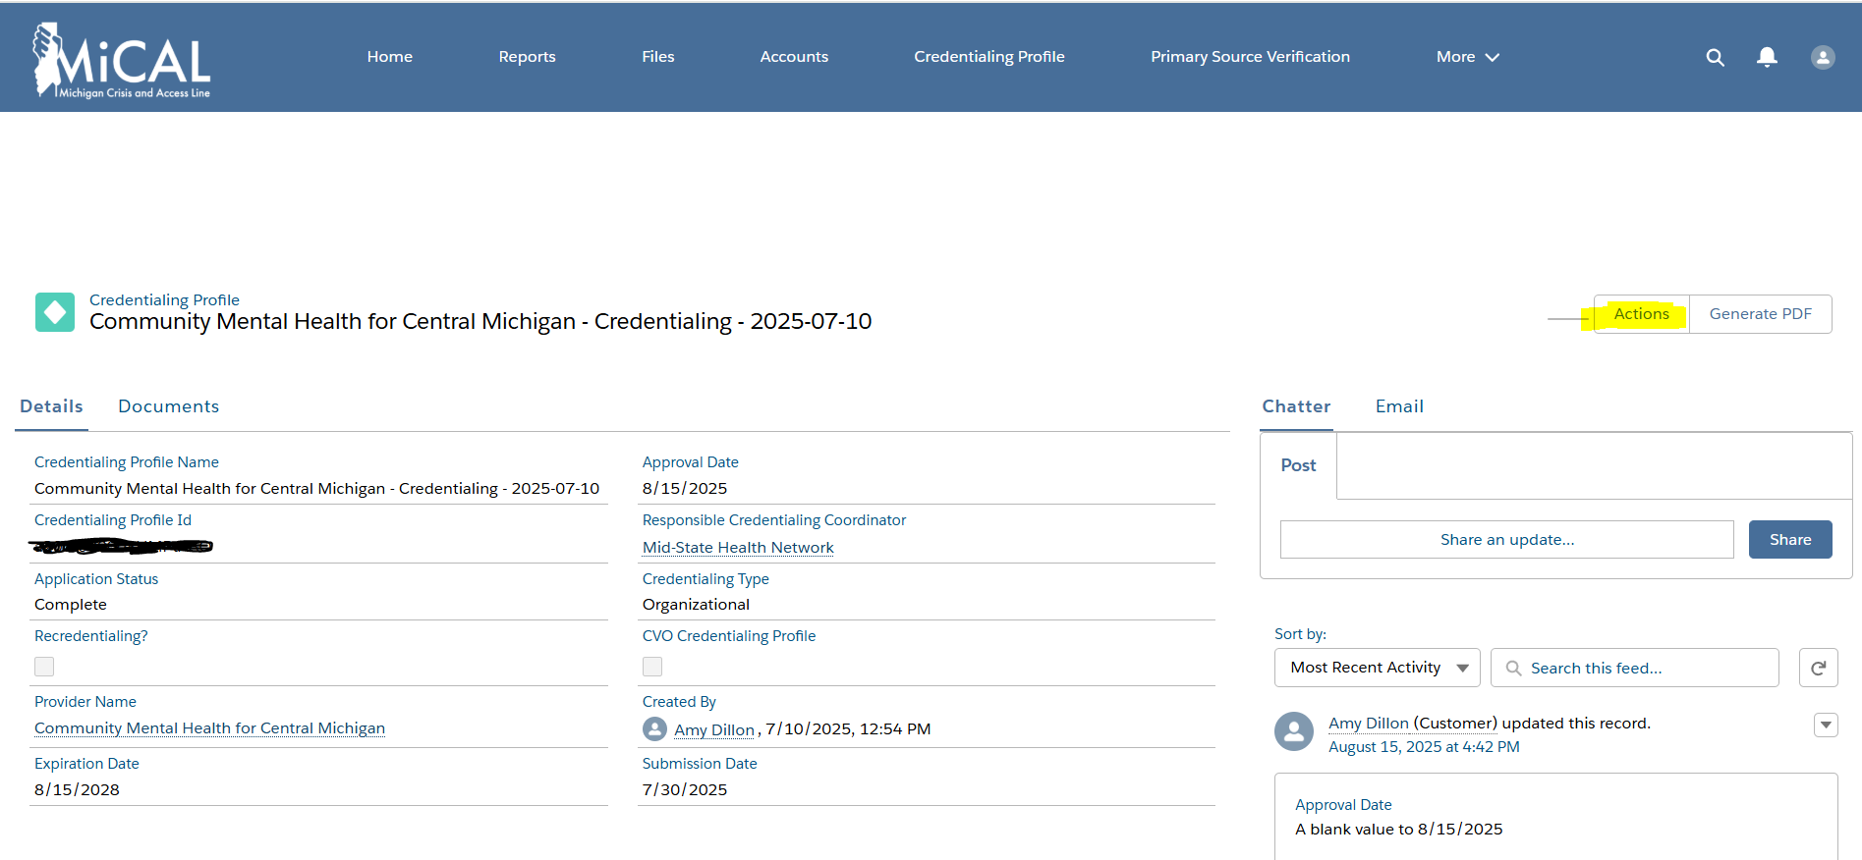
13. | A pop up will appear. Select Edit Application.  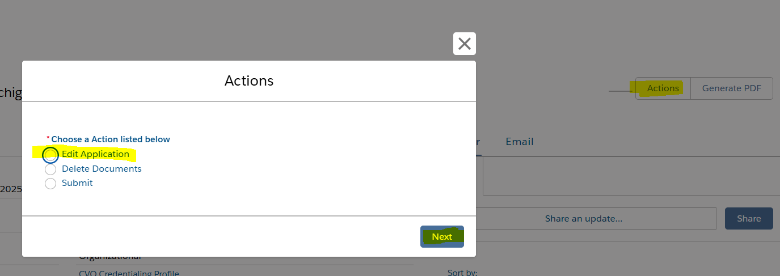
14. | A list of Actions will appear. You will need to address each one. You can only address one at a time. Click Credentialing Contacts then click Next.  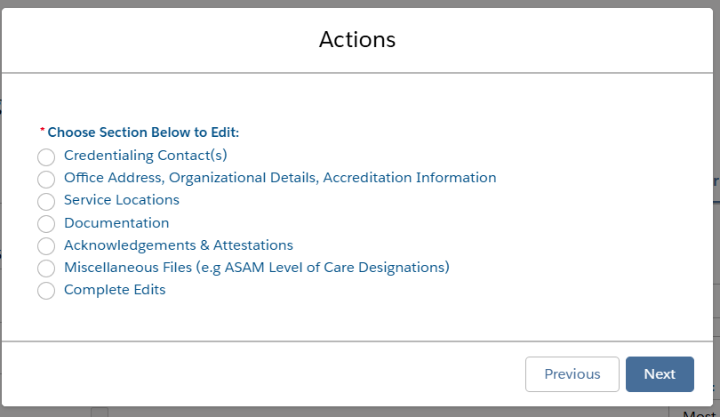
15. | Credentialing Contacts are any individual from the Organizational Provider who will be working on completing the Credentialing Profile. If all contacts are correct, click Next. The user will be directed back to the above list of actions.
16. | From the above list, click the button to the left of Office Address, Organizational Details, Accreditation Information and click Next.  Complete all required and applicable sections.  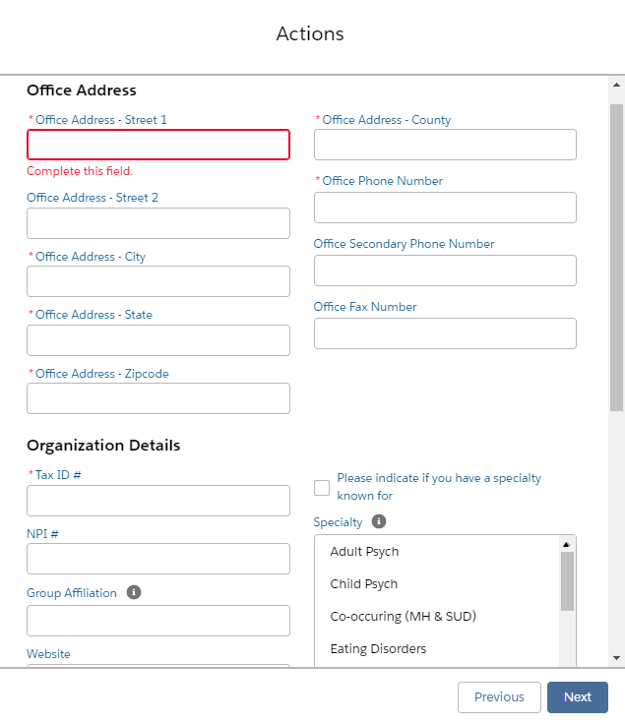  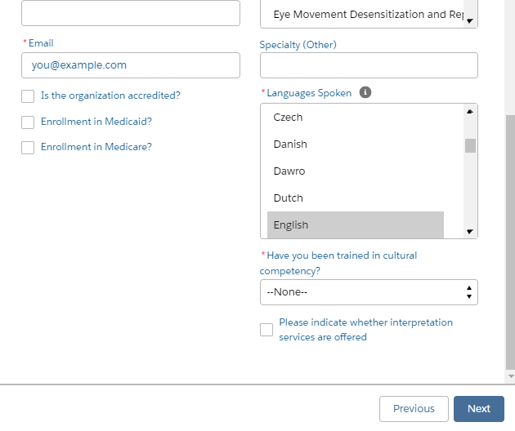  If Is the organization accredited? is checked, the following will also appear:  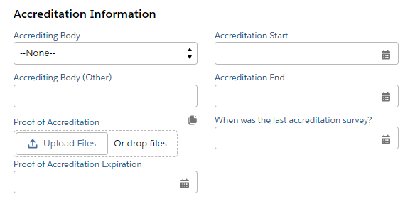  Once completed, click Next. A message will display informing the user that this section has successfully been updated. The user will be directed back to the above list of actions.
17. | From the above list, click the button to the left of Service Locations, then click Next.  (Click here for step-by-step instructions on how to complete Service Locations)  Once completed, click Next. The user will be directed back to the above list of actions.
18. | From the above list, click the button to the left of Documentation, then click Next.  Complete all the required and applicable sections.  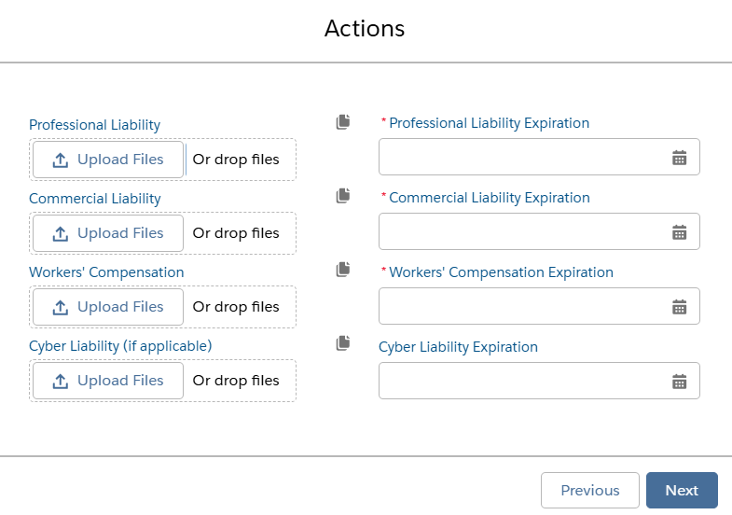  Once completed, click Next. A message will display informing the user that this section has successfully been updated. The user will be directed back to the above list of actions.
19. | From the above list, click the button to the left of Acknowledgements & Attestations, then click Next.  Complete all required and applicable sections.  If “Yes” is selected for any of the questions, an “Explanation” is required.  Once completed, click Next. A message will display informing the user that this section has successfully been updated. The user will be directed back to the above list of actions.
20. | From the above list, if there are additional files to upload, click the button to the left of Miscellaneous Files, then click Next.  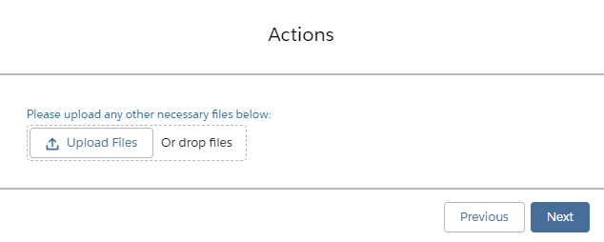  User may upload as many files as necessary via the file upload box. “Files uploaded successfully” will display and the user will be directed back to the above list of actions.
21. | From the above list, click the button to the left of Complete Edits, then click Next.  A message indicating “Successfully Edited the Credential Application of (Organizational Provider) – Credentialing – Date) Click Finish to View Edits” will display.  Click Next.
22. | Review all information for accuracy. If all information is accurate and edits have been completed, click Actions.
23. | Click Submit, then click Next.  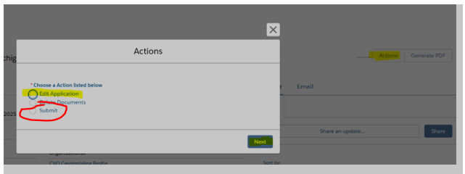
24. | Select Yes to consent to the provided statement, then click Next.  *If No is selected, user will be directed back to the Credentialing Profile.

