ADMINISTRATIVE GUIDELINE

In an effort to promote medication safety and reduce the risk of medication errors, Community Mental Health for Central Michigan (CMHCM) has identified a process to address sound-alike and look-alike drugs. The Medical Director and Nurse Administrator will review and update the list included with this guideline annually and identify measures as needed to reduce the risk of errors involving look-alike and sound-alike medications.

Each CMHCM site where medications are distributed or administered will have access to the current list and will implement appropriate measures to reduce the risk of look-alike/sound-alike medication errors. This plan may consist of but not be limited to:
- Listing both the brand and generic names on medication records.
- Storing products with look-alike or sound-alike names in different locations.
- Employing double checks in the distribution process.
- Affixing “name alert” stickers to areas where look-alike or sound-alike products are stored.
- Changing the appearance of look-alike product names on pharmacy labels, computer screens, shelf labels and bins, and medication records by highlighting, through bold face, color, and/or tall man letters, the parts of the names that are different (e.g. hydrOXYzine, hydrALAzine).
- Having physicians write prescriptions using both the brand and generic names.
- Alerting consumers to the potential for mix-ups.
- Encouraging patients and direct care staff to question pharmacists and nurses about medications that are unfamiliar or look or sound different than expected.

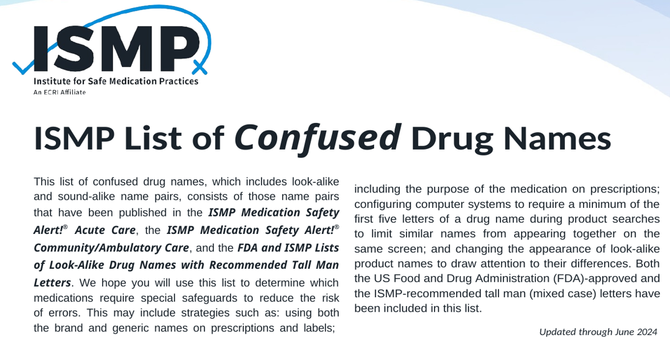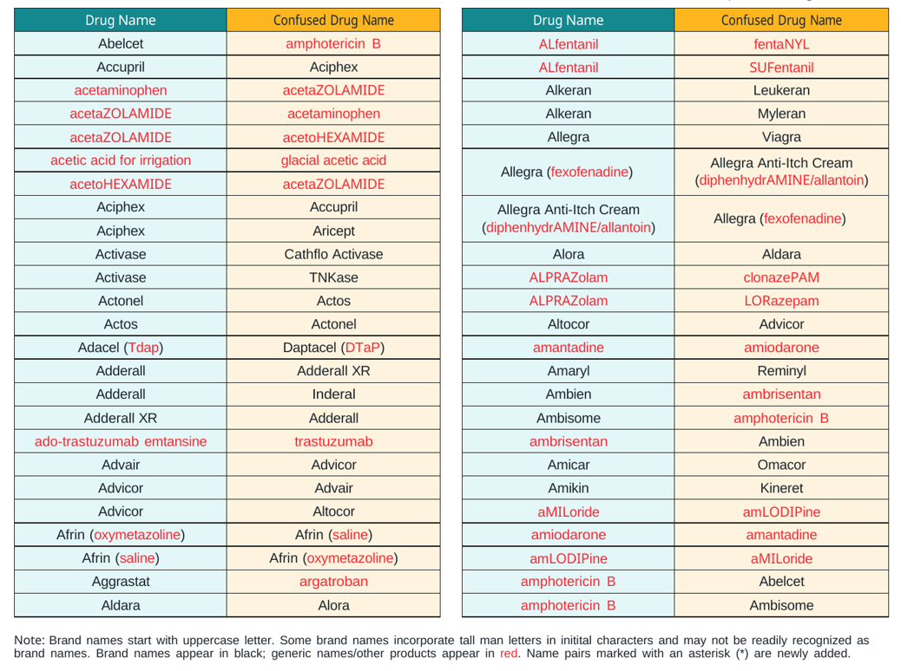
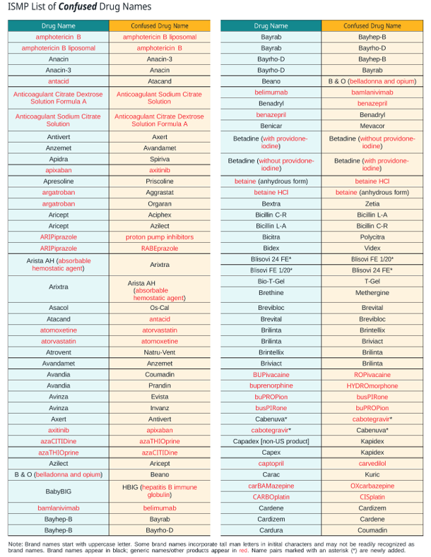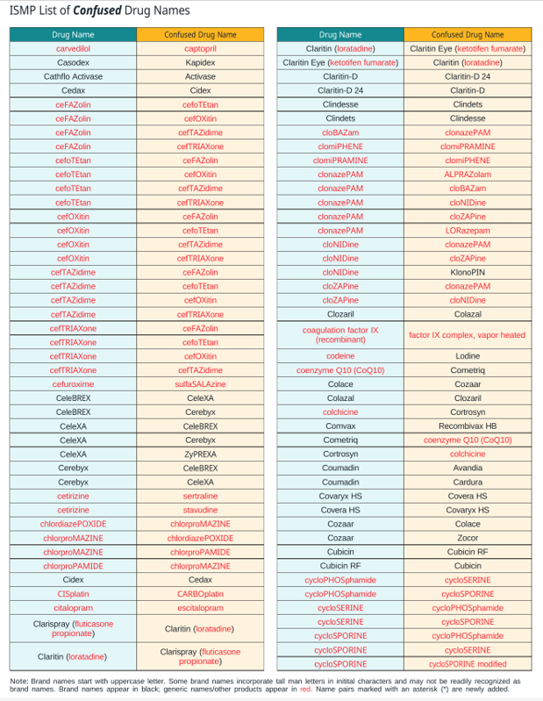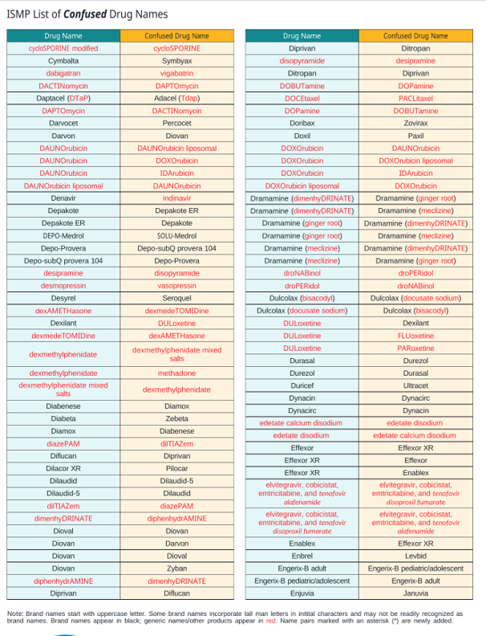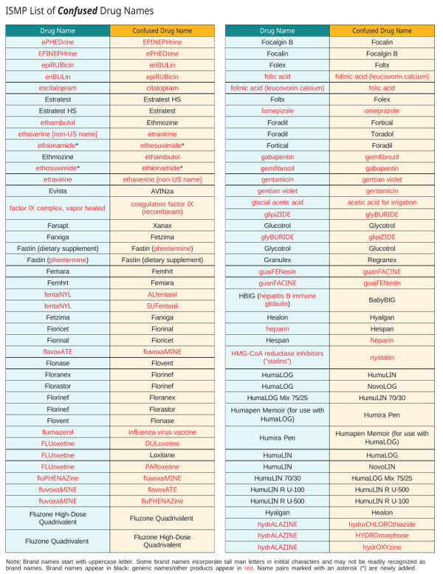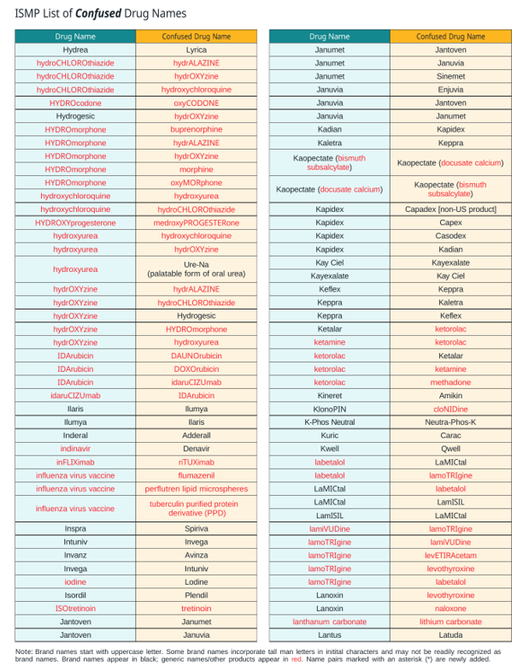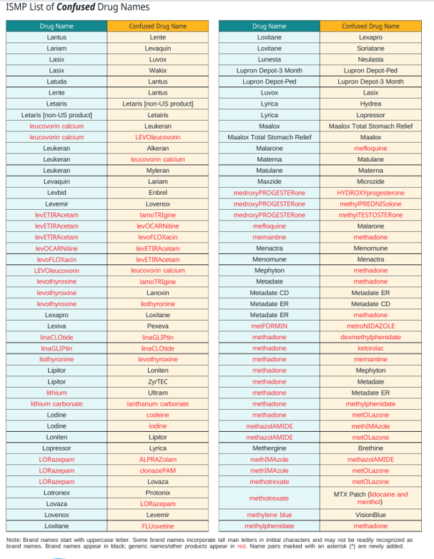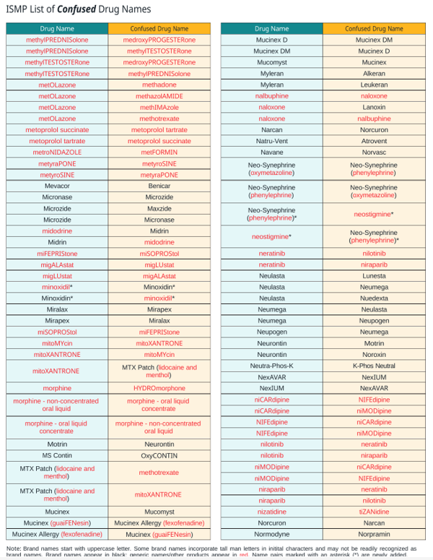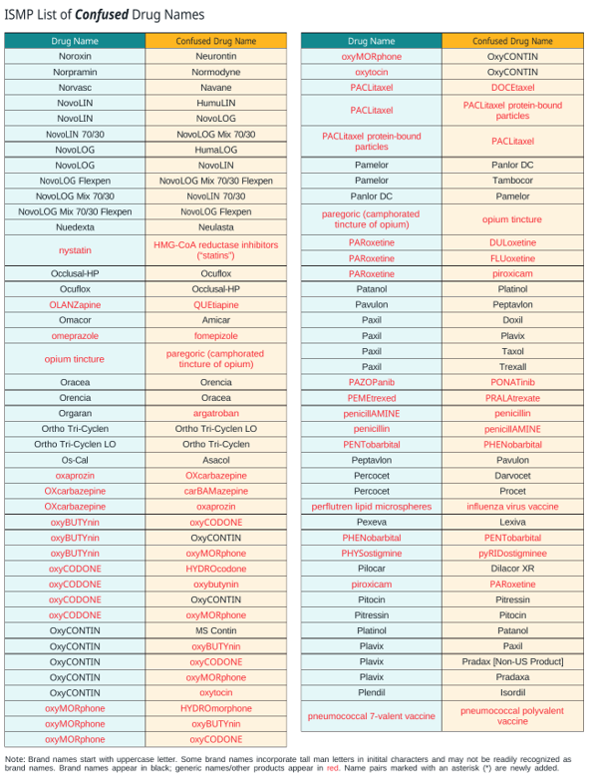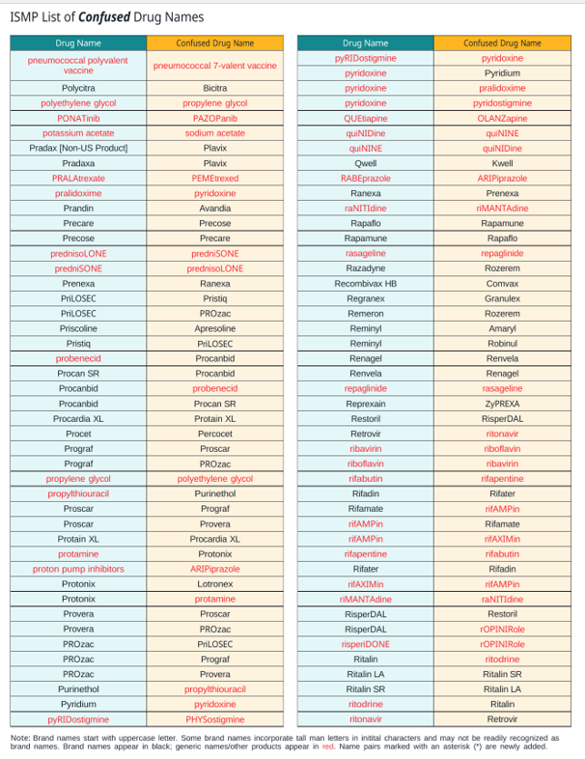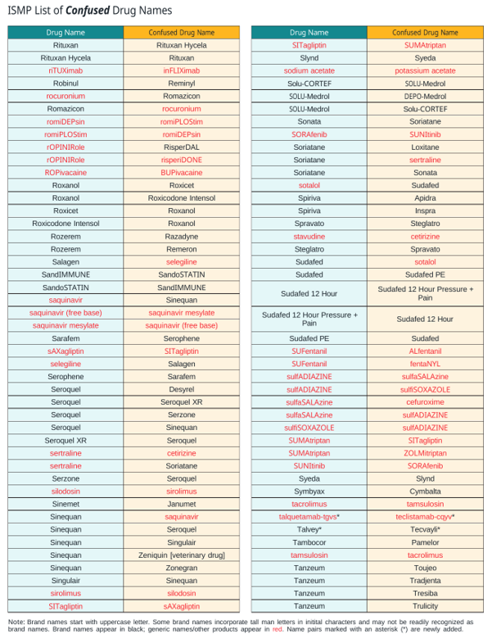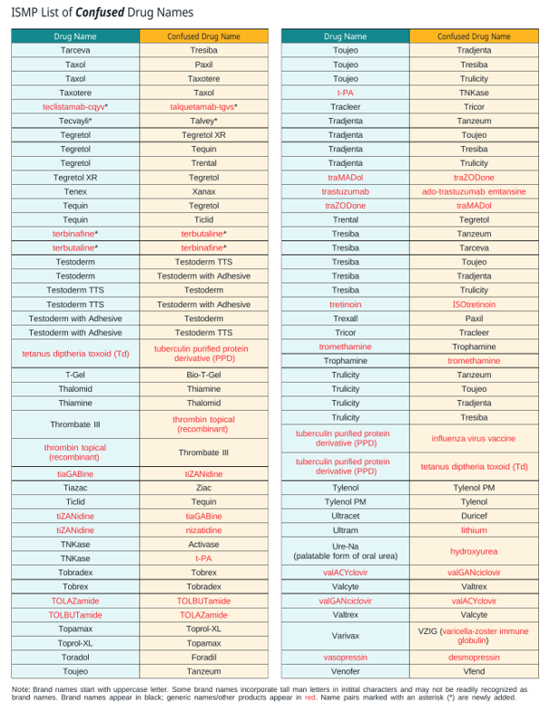
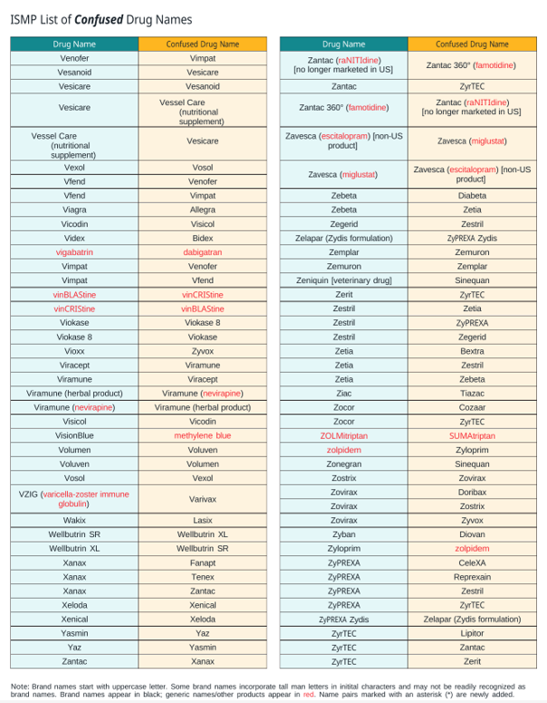
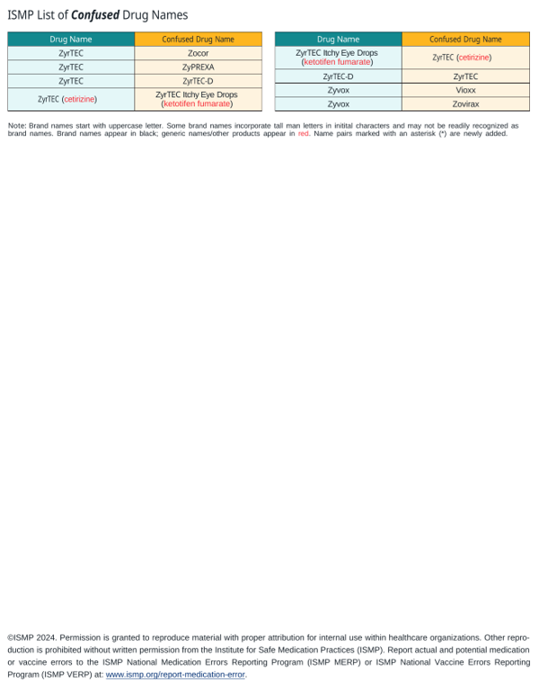

*These drugs have been discontinued and are not marketed in the United States.
^{† These} drug names are also on the FDA list.
‡ Brand names always start with an uppercase letter. Some brand names incorporate tall man letters in initial characters and may not be readily recognized as brand names. A double dagger follows all brand names on the ISMP list.
To promote standardization regarding which letters to present in uppercase, ISMP follows a tested methodology whenever possible called the CD3 rule.15 The methodology suggests working from the left of the drug name first by capitalizing all the characters to the right once 2 or more dissimilar letters are encountered, and then, working from the right, returning 2 or more letters common to both words to lowercase letters. When the rule cannot be applied because there are no common letters on the right side of the name, the methodology suggests capitalizing the central part of the word only. When application of this rule fails to lead to the best tall man lettering option (e.g., makes names appear too similar, makes names hard to read based on pronunciation), an alternative option is considered. ISMP suggests that the bolded, tall man lettering scheme provided by FDA and ISMP for the drug name pairs listed in Tables 1 and 2 be followed to promote consistency.

Brand names always start with an uppercase letter. Some brand names incorporate tall man letters in initial characters and may not be readily recognized as brand names. An asterisk follows all brand names on the ISMP list.
** These drug names are also on the FDA list.
*** The ISMP list is not an official list approved by FDA. It is intended for voluntary use by healthcare practitioners and drug information and technology vendors. Any manufacturers’ product label changes require FDA approval.

Approved by ELT: 4/01/05
Revised: 3/19/07, 6/10/10, 5/24/21, 8/10/23, 1/8/25, 08/19/26

