- PURPOSE: To establish policies and procedures to handle denial of hospitalization; denial of access to programs/services offered by Community Mental Health for Central Michigan (CMHCM); and denial of Family Support Subsidy.

- APPLICATION: The policies and procedures stated herein apply to all applicants, and consumers of service.

- REFERENCES:
  - The Medicaid Managed Specialty Supports and Services Concurrent 1915(i)/(c) 1115 Waiver Program(s), the 1115 Healthy Michigan Plan and Substance Use Disorder Community Grant Programs Agreement with Mid-State Health Network
  - Michigan Department of Health and Human Services (MDHHS)/Community Mental Health Service Program (CMHSP) Managed Mental Health Support and Services Contract
  - MDHHS Administrative Rule 330.7005.
  - Michigan Mental Health Code, Act 258 of the Public Act of 1974, as amended, 330.1159, 330.1409(4), 330.1498e(4), 330.1498h(5), and 330.1705.
  - Administrative Procedures Act of 1969, Act No. 306 of the Public Acts of 1969, being sections 24.271 to 24.287 of the Michigan Complied Laws.
  - Michigan Department of Health and Human Services Care Grievance and Appeal Technical Advisory.
  - Memo from DMH 4-10-1985 - Family Support Subsidy Appeals.
  - MDHHS Your Rights When Receiving Mental Health Services in Michigan Handbook (page 9).

- DEFINITIONS:

- ADEQUATE NOTICE | Written statement provided to an applicant or consumer no later than the date of action when there is a denial of hospitalization. Written statement provided to the applicant no later than the date of action when there is a denial of services.
B. APPLICANT | An individual who is not currently receiving any mental health services or their legal representative who makes an initial request for mental health services.
C. DENIAL (ELIGIBLE FOR SECOND OPINION) | Refusal to authorize any CMHCM services to a new applicant for services or refusal to authorize hospitalization or Family Support Subsidy.
D. CONSUMER | Broad, inclusive reference to an individual requesting or receiving mental health services delivered and/or managed by CMHCM, including Medicaid beneficiaries, and all others receiving CMHCM services.

- POLICY:
  - When an applicant for CMHCM services is denied services, the applicant, their guardian, designated patient advocate, or the applicant’s parent in the case of a minor, shall be informed of their right to request a second opinion from the Executive Director.
  - When an applicant or current consumer is denied hospitalization services, the individual, their guardian, designated patient advocate, or the individual’s parent in the case of a minor, shall be informed of their right to request a second opinion from the Executive Director.
  - When a Family Support Subsidy application is denied or a family support subsidy is terminated the parent or legal guardian of the affected eligible minor may request a second opinion from the Executive Director.

- PROCEDURE:
  - Denial of Hospitalization (Appendix A):
- If the pre-admission screening unit or children's mobile crisis team denies hospitalization, the individual, their guardian or their parent in the case of a minor child, must be informed of that decision and be given adequate notice of the right to request a second opinion from the CMCHM Executive Director.
- The individual, their guardian or their parent in the case of a minor child must be notified immediately of the right to request a second opinion. A letter explaining their rights to a second opinion is provided at the time of the denial.
- If the initial request for inpatient admission is denied, and the individual is a current consumer of other CMCMH services, the individual or someone on their behalf may file a complaint with the CMHCM Office of Recipient Rights alleging a violation of their right to treatment suited to condition (see CMHCM Policy 7.300.002).
- Written requests are preferred; however, if an individual is not able to complete a written request, the individual may request assistance from CMHCM Customer Services, Office of Recipient Rights, or any other staff person.
- Send (via fax or email) second opinion requests to the Executive Director the day the request is received (either written by the individual or given verbally to a CMHCM staff person who will submit a written request to the Executive Director on their behalf) with a copy to the Executive Coordinator and Customer Services staff.
- Upon receipt of the request for a second opinion, the request shall be entered into a log maintained by the Executive Coordinator.
- The Executive Director/designee, in conjunction with the Medical Director, shall arrange for a second opinion by a psychiatrist, other physician, or licensed psychologist within three calendar days, excluding Sundays and legal holidays, after the Executive Director/designee receives the request.
    - Scheduling will occur using a psychiatric rotation.
    - Customer Services, in conjunction with applicable clinical staff, will coordinate with the initial screener for any relevant information that needs to be shared.
    - The consumer will be seen in the office for the second opinion assessment.
    - The result of the second opinion is documented by the psychiatrist who conducted the second opinion in a clinic note in the consumer’s medical chart. The nurse shares the results of the second opinion with Customer Services. Customer Services notifies the Medical Director, CMIT, and the Executive Coordinator of the outcome.
- If the conclusion of the second opinion is different from the conclusion of the children's mobile crisis team or the pre-admission screening unit, the Executive Director/designee, in conjunction with the Medical Director, shall make a decision within one business day based upon all clinical information available.
- If admission is deemed medically necessary, CMIT will coordinate the inpatient admission.
- If the second opinion determines the individual is not clinically suitable for hospitalization and the individual is a current consumer of other CMHCM services, the individual or someone on their behalf may file a complaint with the CMHCM Rights Office (see CMHCM Policy 7.300.002).
- The Executive Director’s decision shall be confirmed in writing to the individual who requested the second opinion, and the confirming document shall include the signatures of the Executive Director/designee and the Medical Director, or verification that the decision was made in conjunction with the Medical Director.
- Each request for services is considered a new request. If a request for inpatient hospitalization is received and an authorization is given for five days of service, and on the fourth day the individual requests three more days, that request is treated as a new request and if denied, requires adequate notice. The denied new request for the three days would allow the applicant to request a second opinion.
B. Denial of Access to Community Mental Health for Central Michigan Program Services (Appendix A):
    - If an initial applicant for CMHCM services is denied such services, the applicant or their guardian, or the applicant's parent in the case of a minor must be informed of that decision and be given adequate notice of their right to request a second opinion from the CMHCM Executive Director.
    - The request for a second opinion shall be within 45 days of the denial of services. Written requests are preferred; however, if an individual is not able to complete a written request, the individual may request assistance from the CMHCM Customer Services, Office of Recipient Rights, or any other staff person.
    - Send (via fax or email) second opinion requests to the Executive Director the day the request is received (either written by the individual or given verbally to a CMHCM staff person who will submit a written request to the Executive Director on their behalf) with a copy to the Executive Coordinator and Customer Services staff.
    - Upon receipt of the request for a second opinion, the request shall be entered into a log maintained by the Executive Coordinator.
    - The Executive Director/designee shall secure the second opinion from a physician, licensed psychologist, registered professional nurse, Master’s level licensed social worker, or Master’s level licensed psychologist within five business days.
    - If the individual providing the second opinion review determines that the applicant has a serious mental illness, serious emotional disturbance, or an intellectual/developmental disability, or is experiencing an emergency situation or urgent situation, services shall be offered to the applicant. The reviewer completes an update to the assessment reflecting the change in the disposition.
    - If the individual providing the second opinion review upholds the original decision and determines that the applicant does not have a serious mental illness, serious emotional disturbance, or an intellectual/developmental disability, and is not experiencing an emergent or urgent situation, the reviewer completes the second opinion form and scans it into the consumer’s record.
    - The Executive Director’s decision shall be confirmed in writing to the individual who requested the second opinion.
    - The applicant may not file a recipient rights complaint for denial of services suited to condition as they do not have standing as a consumer of mental health services. He or she may, however, file a rights complaint if the request for a second opinion is denied. (See CMHCM Policy 7.200.003.)
C. Denial of Family Support Subsidy (Appendix B):
1. Copies of blank application forms, parent report forms, the forms for changed family circumstances, and appeal forms shall be available from CMHCM.
2. CMHCM shall review an application and promptly approve or deny the application and shall provide written notice to the applicant of its action and of the opportunity to administratively appeal the decision if the decision is to deny the application.
- If the denial is due to the insufficiency of the information on the application form or the required appendix, the agency shall identify the insufficiency.
- If an application for a family support subsidy is denied or a family support subsidy is terminated, the parent or legal guardian of the affected eligible minor may request, in writing, a hearing with CMHCM.
- The written appeal shall be filed with the CMHCM Executive Director within two months of the notice of denial or termination.
- The hearing shall be conducted in the same manner as provided for contested case hearing under Chapter 4 of the Administrative Procedures Act of 1969.
- Upon receipt of the request for appeal, the request shall be entered into a log maintained by the Executive Director/designee.
- A receipt of Appeal shall be sent to the individual indicating the information about the scheduled hearing, or a response indicating that the appeal was not received within two months of the action. The notice of the hearing shall include:
    - Date, hour, place and nature of hearing.
    - Statement of legal authority and jurisdiction under which the hearing is to be held.
    - Reference to statutes and rules involved.
    - Short and plain statement of the matters asserted.
- The Executive Director/designee shall:
    - Preside as the hearing officer.
    - Not talk with one side regarding the contested case without the other being present.
    - Not do any investigation or fact-finding, (each side must show the director/designee why that side should prevail).
    - Become familiar with the law and rules governing the contested matter.
    - Read the correspondence from both sides prior to the hearing.
- The hearing shall be tape-recorded. The Executive Director/designee shall begin the tape by identifying the date, time, place, and nature of the appeal.
- The Executive Director/designee will state the processes:
    - I will ask all parties present to identify themselves for the record (names and functions - include self).
    - I will swear in all those present who may want to say something.
    - I will show you this file and ask if you object to anything that it contains - there should only be items which both parties have received or of which they had notice.
    - I will ask the representative from Family Support Subsidy Program to explain why they denied or terminated the family from the subsidy program.
    - I will ask the family if they have questions about what the Family Support Subsidy person has said.
    - I will ask the family to explain what the Family Support Subsidy Program should have considered - but didn't.
    - I will ask the Family Support Subsidy program representative if there are any questions about what the family said.
    - I will then ask each party if it has anything to add.
    - Finally, I will announce my findings today, and give you a decision that will end this hearing (or) I will go back to my office and issue a written opinion as to my findings of facts and conclusions of law and give you a decision within five business days. If you do not agree with my decision at the time the decision is made, you may appeal to circuit court.
- Proceed with the hearing, with consideration of the following recommendations:
    - All those present should identify themselves - even if they don't plan to speak.
    - The swearing in can be done as a group. Encourage even those not planning to speak to respond. Say to them: Raise your right hand. Do you affirm or swear that you will tell the truth, the whole truth, and nothing but the truth? If so answer, I do.
    - Open the file, identify each item, then hand each to pass around. For example, "This is the original appeal complete with appendices which came to our office. Please look at it." After all items have been looked at, ask whether anyone objects to anything in this file.
    - Ask the Family Support Subsidy Program person to explain why the family was denied or terminated. If family interrupts, ask them to wait - they will have a turn. Throughout the hearing, the Presiding Officer may choose whether to ask questions for clarification or to leave the burden of clarification to the other side.
    - Ask the family if they have questions - for clarification or additional information. Keep everyone on task. Allow only questions right now - they will have an opportunity to make their statement. Try not to allow interruptions. Remind parties they must be testifying, questioning or addressing the presiding officer and not debating each other.
    - Ask the family to explain what the Family Support Subsidy Program should have considered.
    - Allow questions from the Family Support Subsidy Program person.
    - Allow the final remarks from both sides.
    - The Presiding Officer may choose whether to give the findings of fact and the conclusions of law orally at the end of the hearing or issue a written decision. If the Presiding Officer is not fully familiar with the law, the format, and the process, a written finding, conclusion and decision might be preferable.
    - The written decision is to be issued within five business days.
    - If an individual fails to appear, and no adjournment is granted, the Executive Director/designee may proceed with the hearing.
Date Approved: 10/1/01
Revised: 11/26/02, 3/31/09, 8/25/09, 6/15/17, 10/11/18, 5/14/20, 1/11/24
APPENDIX A

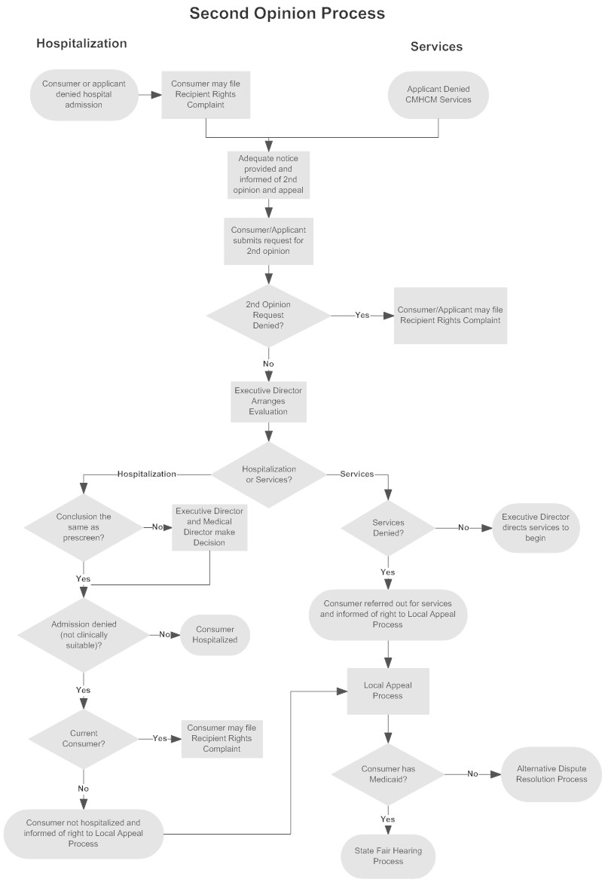

APPENDIX B

