(3/5/25)
BOTH (IPOS and ABA Plan) training records need to be completed prior to working with the Consumer

ABA Treatment Plan / Assessment Training Record
- To be completed every time a new ABA Treatment Plan / Assessment is done
- All person(s) working with this Consumer need to be trained on this plan prior to working with him/her
- Staff names need to be their legal name AND be legible (this does not need to be a signature)
- A new training record needs to be completed each date a training occurs.
- This completed form needs to be uploaded as an attachment to the applicable ABA Treatment Plan/Assessment in CIGMMO.

- Consumer’s full name
- Consumer’s date of birth
- Consumer’s CMHCM ID (can be found in the Consumer’s CIGMMO chart or obtain from the Case Manager)
- The agency that the staff being trained work at
- The date that this ABA Treatment Plan/Assessment was completed
- This should be the author of the ABA Treatment Plan/Assessment OR someone else who has previously been trained by the author of the ABA Treatment Plan/Assessment AND the trainer’s title (BCBA, BCaBA, etc.) – PRINT LEGIBLY and SIGN
- The date this training took place (the date that the staff listed below were trained on this plan)

IPOS Training Record (paper version)
- When a Consumer begins ABA services (and when a new IPOS is put into effect), the author of the IPOS will train at least one person working with the Consumer and they will complete a training record listing themselves as the trainer. After this initial training, the ‘trained’ staff can train others and complete their own training record listing themselves as the trainer.
- A new training record needs to be completed each date a training occurs.
- All person(s) working with this Consumer need to be trained on this plan prior to working with him/her
- Staff names need to be their legal name AND be legible (this does not need to be a signature)

- Consumer’s full name
- Consumer’s date of birth
- Consumer’s CMHCM ID (can be found in the Consumer’s CIGMMO chart or obtain from the Case Manager)
- The agency that the staff being trained work at
- The date that this IPOS is effective as shown on page 1 of the plan (this is not necessarily the date of the PCP meeting)
- This should be someone who has previously been trained by the Case Manager - PRINT LEGIBLY AND SIGN
- The title of the trainer on this record (BCBA, BCaBA, Director, Lead Staff, etc.)
- The date this training took place (the date that the staff listed below were trained on this plan)

IPOS / Addendum Training Record (CIGMMO electronic version)
- If an electronic IPOS training record is completed in CIGMMO, a paper version of the training record does not need to be uploaded.
- Select the IPOS that will be trained on and click on ‘Add PCP Training Record’.

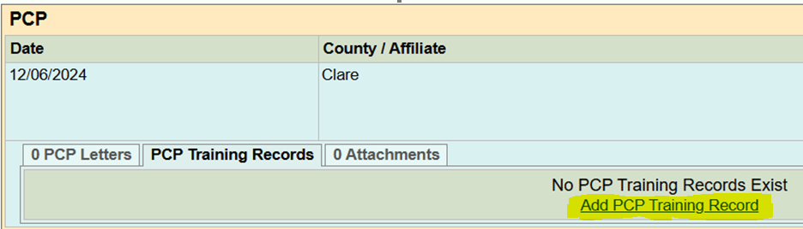

- The person training the staff will enter the highlighted information below with the date that the staff listed were trained on this plan
- Click ‘Sign and Save’



